4.1 Experiment No. : 04
4.2 Experiment Name : Application of HTML div and CSS Flexbox
4.3 Theory
This experiment demonstrates the use of HTML <div> elements combined with CSS Flexbox for creating structured, responsive, and visually balanced web layouts. <div> elements act as generic containers that allow grouping of content for styling and positional control. By themselves, <div> tags have no visual styling, but when combined with CSS, they provide the foundation for modern web interfaces.
Core Concepts
- Flexbox for Layout
  - CSS Flexbox is a one-dimensional layout model that arranges elements in rows or columns and distributes space efficiently within a container.
  - Flex properties such as justify-content, align-items, and flex-direction enable precise control over alignment, spacing, and distribution of elements.
- Container and Item Relationship
  - Flexbox works on the principle of containers and items: the container defines the layout behavior, while items adapt their size and position according to the container rules.
  - Nested containers allow the creation of complex layouts while maintaining simplicity and flexibility.
- Responsiveness and Adaptability
  - Flexbox enables layouts to adjust dynamically based on screen size, making web pages responsive across desktops, tablets, and mobile devices.
  - Items can grow, shrink, or wrap to fit the available space, improving usability and readability.
- Separation of Structure and Presentation
  - <div> elements define the structural hierarchy of content, while CSS handles presentation and alignment.
  - This separation supports maintainable, modular, and scalable web design.
Advantages of Flexbox
- Simplifies complex layouts compared to traditional methods like floats or tables.
- Provides clean alignment and spacing without relying on hard-coded measurements.
- Supports modern web design principles, including accessibility, visual hierarchy, and responsiveness.
Applications
- Creating navigation bars, cards, and content sections.
- Aligning elements in headers, footers, and main content areas.
- Building responsive interfaces that adapt to various devices automatically.

4.4 Problem Statement
Imagine a small web design team tasked with creating a modern dashboard for a client. They need a flexible layout where different content blocks can be arranged neatly side-by-side or stacked, while still looking good on any device. Your task is to create a webpage using HTML <div> elements and CSS Flexbox that achieves this. The page should demonstrate proper alignment, spacing, and responsiveness, with visually distinct content sections using background colors, padding, and centered text.

4.5 Source Code
<!DOCTYPE html>
<html lang="en">
<head>
<meta charset="UTF-8" />
<meta name="viewport" content="width=device-width, initial-scale=1.0" />
<title>Fancy RGB Layout</title>
<style>
body {
font-family: Arial, sans-serif;
background: #f6f8fa;
display: flex;
justify-content: center;
align-items: center;
min-height: 100vh;
margin: 0;
}

.container {
display: grid;
gap: 12px;
padding: 20px;
border-radius: 16px;
background: white;
box-shadow: 0 4px 20px rgba(0, 0, 0, 0.1);
}

/* First row (R, G, B side by side) */
.row1 {
display: grid;
grid-template-columns: repeat(3, 1fr);
gap: 12px;
}

/* Second row (column of R/G + tall B) */
.row2 {
display: grid;
grid-template-columns: 75px 1fr;
gap: 12px;
align-items: stretch;
}

.col-stack {
display: grid;
grid-template-rows: 1fr 1fr; /* equal halves */
gap: 12px;
}

.box {
padding: 10px;
display: flex;
justify-content: center;
align-items: center;
font-weight: bold;
font-size: 20px;
border-radius: 12px;
color: white;
box-shadow: 0 3px 6px rgba(0, 0, 0, 0.1);
}

.R {
background: #e74c3c;
}
.G {
background: #2ecc71;
}
.B {
background: #3498db;
}

.second-blue {
display: flex;
align-items: center;
justify-content: center;
min-height: 132px;
}
@media (prefers-color-scheme: dark) {
body {
background: #1e1e1e;
color: #f0f0f0;
}

.container {
background: #2c2c2c;
box-shadow: 0 4px 20px rgba(0, 0, 0, 0.7);
}

.box {
box-shadow: 0 3px 6px rgba(0, 0, 0, 0.7);
}
}
</style>
</head>
<body>
<div class="container">
<div class="row1">
<div class="box R">R</div>
<div class="box G">G</div>
<div class="box B">B</div>
</div>
<div class="row2">
<div class="col-stack">
<div class="box R">R</div>
<div class="box G">G</div>
</div>
<div class="box B second-blue">B</div>
</div>
</div>
</body>
</html>

4.6 Output
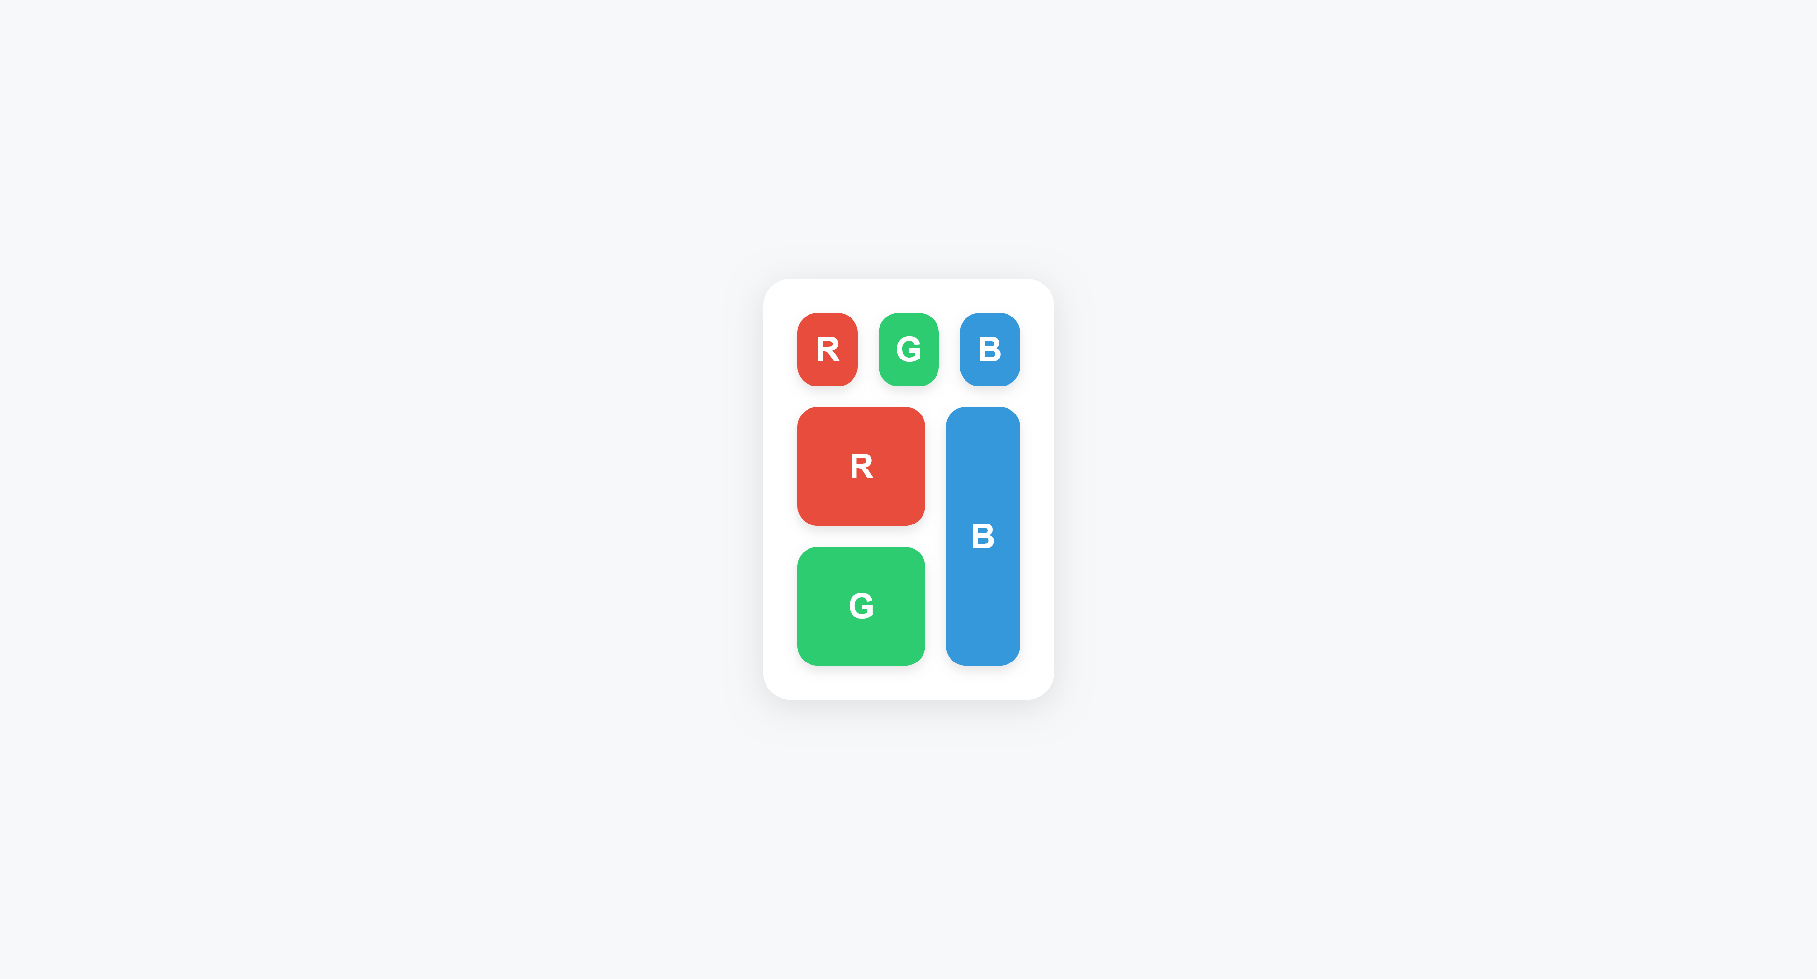
Fig 4.1: Light Version of the Website

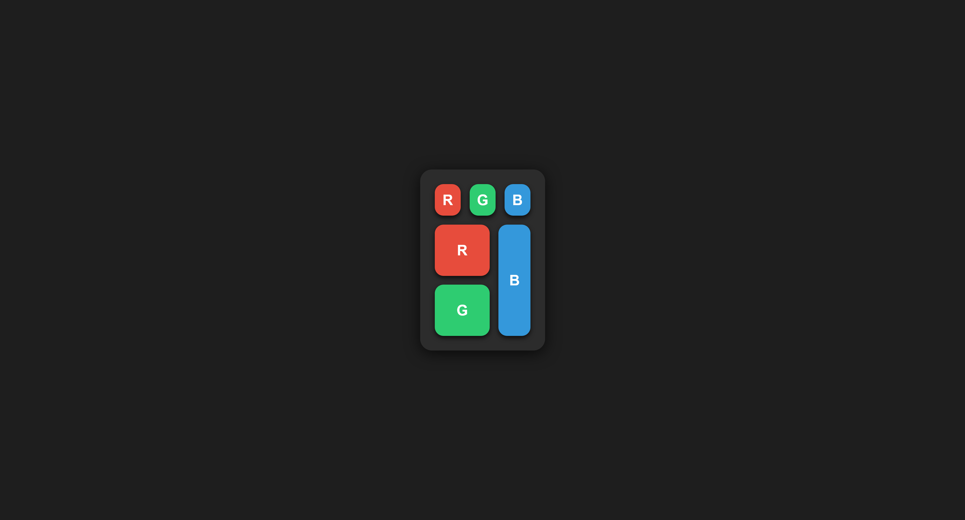
Fig 4.2: Dark Version of the Website

4.7 Discussion
The experiment was conducted to demonstrate the use of flexbox and <div> elements for creating flexible and responsive layouts, and visual hierarchy was established through color and positioning. Elements were organized into rows and columns using flexbox to achieve clarity while maintaining aesthetic appeal.
In the first row, three equally sized boxes—representing Red, Green, and Blue—were displayed side by side. Equal distribution of space was achieved using flexbox properties, and the primary color components were emphasized.
In the second row, a nested flex structure was implemented, where a stacked combination of Red and Green was placed in the left column, and a taller Blue box was positioned in the right column. The second Blue box was made to span the full width, illustrating the ability to control alignment, sizing, and spacing using flexbox.
A dark mode was added using the prefers-color-scheme media query. Background and box-shadow colors were adjusted to improve readability in low-light environments and reduce eye strain. Smooth transitions were applied so that theme changes were visually appealing.
Through this experiment, several front-end concepts were reinforced:
- Flexbox Layouts were applied to efficiently manage multi-row and multi-column arrangements.
- Nested Flex Containers were utilized to enable stacking and hierarchical organization of elements.
- Responsive Design principles were implemented to adjust spacing and alignment based on container size.
The experiment provided a foundation for understanding how flexbox and <div> elements can be used to create structured and responsive user interfaces.

